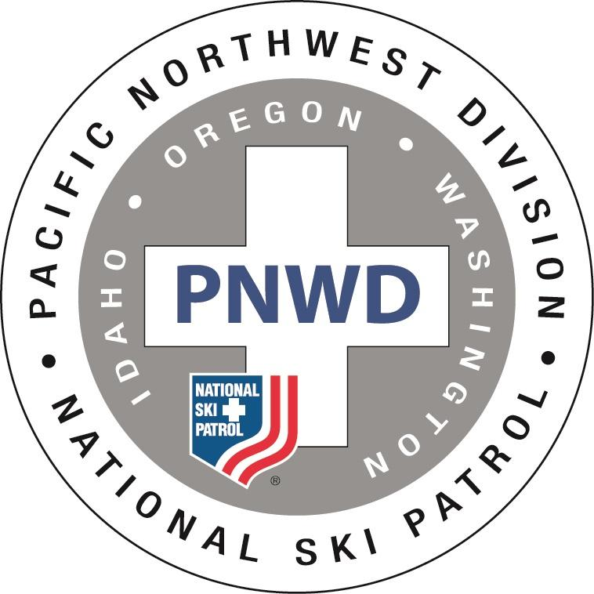
Better Together

PNWD Convention
August 12-14, 2022
Portland, Oregon

Convention Registration
Checks Payable To: PNWD 2022 Convention

ONE FORM PER PATROLLER
Send form and payment to:
PNWD 2022 Convention
℅ Reba Sharp
14710 NW Oak Hills Dr.
Beaverton, OR 97006

Sheraton Portland Airport
Sheraton Portland Airport
8235 NE Airport Way, Portland, OR 97220
Click this link to book your hotel reservation:
PNWD 2022 Group Rate or contact:
Kimberly Lawson / Group Coordinator
503-335-2857; klawson@sheratonpdx.com
(Do not call the 800 number to book your room)
Room Rate: $139.00 for 8/8/22 - 8/17/22
Last day to book: August 4
Name ________________________________ Patrol ______________________________________
NSP # ________________________________ Region ______________________________________
National/LCA Appt. Number _______________ Office/Title / Level _____________________________
Spouse/Guest _________________________ E-Mail ______________________________________
Address ______________________________ Phone ______________________________________
______________________________ I am staying at the Sheraton Hotel [ ] Yes [ ] No
Mt Hood Ski Patrol Member # _____________

Number Cost Amount
Registration - until 7/22/22 _______ $ 60.00 (patroller) ________
Late Registration 7/23/22 and after _______ $ 75.00 (patroller) ________
(No guarantee meals will be available after 7/22)
Friday Dinner - Food Kart Stations _______ $ 25.00 per person ________
Choose one for each person
Soft Taco ____ Wings ____ Falafel ____
Saturday Breakfast _______ $ 18.00 per person ________
Saturday Lunch _______ $ 20.00 per person ________
Saturday Banquet _______ $ 35.00 per person ________
Choose one for each person
Alaskan Cod ____ Chicken Marsala ____ Red Wine Braised Beef ____ Vegan ____

Sunday Breakfast _______ $ 18.00 per person ________

Other: (No cost - please check to confirm attendance)
Patrol Director Training (PD101) - Friday Morning _____ $ 0
OEC Senior Module T/E Clinic – Friday Morning _____ $ 0
NSP Course Number TBD
Total ________

There will be morning meetings for Program Advisors on Saturday and Patrol Directors on Sunday during the breakfast period. Grab your food and head to the assigned breakfast room.

Indicate your interest in any other local activities __________________________________
For more information about the convention and potential extra activities: www.pnwdcon.org

Payment: ☐ Check #_________ ☐ Credit Card (Credit card transactions by phone or US postal mail.)
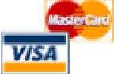
Type: _______ Acct # ________________________ 3 digit Security Code # ______ Exp Date: ________

Card Holder Name (Print): ______________________ Signature: ______________________________
Questions: Reba Sharp, (503) 936-3937, conventionregistration@pnwdcon.org

